

**GHHIN at the International Congress of Biometeorology (ICB) 2017**

**Durham, UK. 4th-7th September 2017**

___________________________________________________________________________

**Summary:**

*Several steering committee members and the GHHIN core team were at the ICB meeting in Durham, UK. This provided the opportunity to socialize the idea to potential members and organize key activities.*

*There was also a chance to introduce GHHIN in a presentation and open forum to the attendees of the conference, which provided a good opportunity to hear feedback from potential users and contributors.*

*A consensus was that GHHIN was moving in the right direction. From around 30 attendees, suggestions were provided and were noted.*

The following events were scheduled for the week:

1. Monday 4th September 12pm – 1:30pm BST: in-person steering committee meeting
2. Tuesday 5th September 6pm – 6:30pm BST: GHHIN introductory presentation and listening session [[Materials available on ghhin.org](http://ghhin.org/home-482254-472850-309027.html)]
3. Wednesday 6th September 12pm – 1pm BST: GHHIN core group discussion

**Key feedback and requests from the week:**

1. A necessary service to this community is facilitating more dialogue in an open forum environment (this is addressed in the GHHIN Engagement Strategy)
2. The 2018 GHHIN Global Forum should be a higher priority
3. A website facility to contribute and track [Heat Health Action Plans](http://ghhin.org/global-heat-health-action-plans.html) is requested.
4. A tracking dashboard of extreme heat events and impacts around the world is requested.
5. The GHHIN steering committee would benefit from improved co-ordination and more frequent action updates between meetings as well as more use of video conferences to the share screen to assist in sharing documents
6. How can we make GHHIN ‘feel real’ – have a visible impact:
   1. Establish a pilot project somewhere
   2. Student exchanges and training opportunities
   3. Collaborate with the HEAT-shield project to track and understand heat’s impacts on labour and productivity
   4. Highlight concrete partners who are participated in active projects relevant to GHHIN

**Material to share:**

1. [PDF of brochure](http://ghhin.org/home-482254-472850-309027.html)
2. [Slides for GHHIN introductory presentation](http://ghhin.org/home-482254-472850-309027.html)

**Monday 4th September 12pm – 1:30pm BST: GHHIN steering committee meeting**

Agenda:

1. Planning of GHINN presentation Tuesday 5th September 2017
2. General discussion on direction of GHHIN

Participants:

1. Kris Ebi
2. Sarah Giltz
3. Hunter Jones
4. Hannah Nissan
5. Glenn McGregor
6. Virginia Murray
7. Robbie Parks
8. Joy Shumake-Guillemot
9. Juli Trtanj

___________________________________________________________________________

1. Planning of GHHIN presentation 5th September 2017

*Agreement that the GHHIN presentation would take the following structure:*

* 20-minute overview of GHHIN, including:
  + Short history of GHHIN
  + Problem GHHIN addresses
  + What GHHIN is
  + What GHHIN will do
  + Invitation for feedback
* 10-minute open discussion for feedback from audience

1. General discussion on direction of GHHIN

* Idea of creating GHHIN collaborating centres with WHO regional offices.
* Agreed upon need to move on from structure of steering and executive committee to planning global forum next year.
* Important short-term priority was to upload stocktaking of Heat Health Action Plans to GHHIN website
* Student exchanges under GHHIN was something that could be done in the near-term without much required funding
* ‘Synthesis report’ now to be referred to as ‘Science and Action synthesis report’

**Tuesday 5th September 2017 6pm – 6:30pm BST: GHHIN introductory presentation**

Agenda

1. Introduce GHHIN to the wider network of biometeorologists at ICB 2017
2. Obtain feedback and suggestions on GHHIN and how it can best serve its aims

Participants

1. Kris Ebi
2. Sarah Giltz
3. Hunter Jones
4. Hannah Nissan
5. Virginia Murray
6. Robbie Parks
7. Joy Shumake-Guillemot
8. Juli Trtanj

___________________________________________________________________________

1. Introduce GHHIN to the wider network of biometeorologists at ICB 2017

*The introduction to GHHIN lasted 20 minutes, was attended by 30 participants, and some specific questions were raised to members of the audience:*

1. *Have we framed the problem correctly?*
2. *What would you find of value to make it worth your while to participate?*
3. *What do you think the community (producers, consumers, facilitators of info) needs?*
4. *Where do you think you fit and can contribute to such a network?*
5. Obtain feedback and suggestions on GHHIN and how it can best serve its aims

*Overall, the reception to GHHIN was positive. Participants in the discussion generally agreed that GHHIN fulfilled a useful purpose (that is, linking local knowledge and solutions globally  
to address the challenges of extreme heat and human health).*

*Some specific comments follow:*

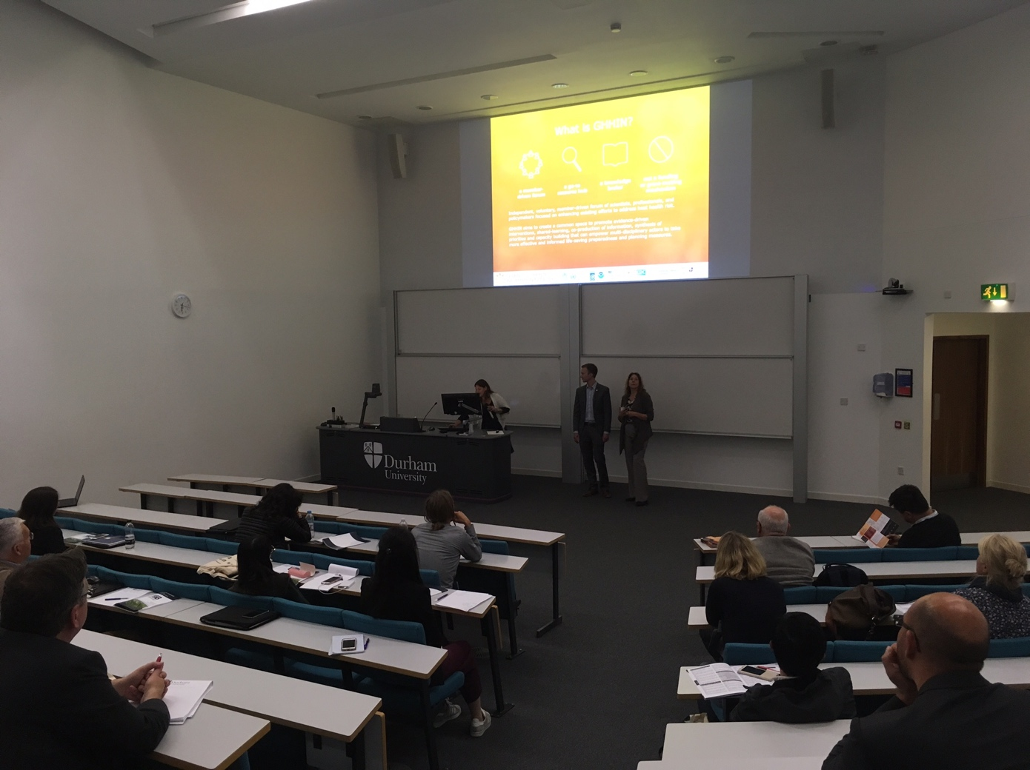

Participants:

* John Nairn:
  + Already great research out there. Operationalization should be the focus of this.
  + Demand community needs an opportunity to add their requests, that are traceable over time.
  + Otherwise it will be difficult to understand if they are fulfilling their targets or not.
* Christina Koppe:
  + How to get smaller countries involved and aware of GHHIN. It is difficult to get to the right people who are working with heat warnings.

* Tord Kjelltstrom:
  + We should try to avoid dominating the health vulnerability focus on just elderly people.
  + Children are important too.
  + Millions of working people are extremely vulnerable but underappreciated. EU founded HEAT-SHIELD to focus on how to protect working people.
* Jane Baldwin:
  + It is important to be able to get people to upload their papers.
  + Tagging and commenting on papers is also important so that people can share their opinions.

**Wednesday 6th September 12pm – 1pm BST: GHHIN core group discussion**

Agenda:

1. Planning for GHHIN Global Forum 2018

Participants:

1. Sarah Giltz
2. Hunter Jones
3. Robbie Parks
4. Joy Shumake-Guillemot
5. Juli Trtanj

___________________________________________________________________________

1. Planning for GHHIN Global Forum 2018

* Finding a venue was still a critical requirement to the planning of the GHHIN Global Forum
* Is the Science and Action synthesis report going to be mainly informed by the discussions at the forum? It may make the report’s evaluation of priorities and good practise more open and democratic.
* The Global Forum is a good place to get content (especially on operations) for the Science and Action Synthesis report.

**Wednesday 6th September 6pm – 8pm BST: GHHIN SC Discussion Continued**

Agenda:

1. Reflecting on feedback and ICB conversations

Participants:

1. Kris Ebi
2. Sarah Giltz
3. Hunter Jones
4. Hannah Nissan
5. Robbie Parks
6. Joy Shumake-Guillemot
7. Juli Trtanj

* We largely discussed how to reprioritize to deliver on the requests at the meeting. Focusing on the GHHIN Forum is an important reprioritization. Thought a lot of thought has gone into the synthesis, it may be more important to focus on delivering a few key services first (outlined at the top of this document) and the GHHIN Forum.